Goal: what is the problem?

RMS Titanic sinking, known as one of the deadliest commercial peacetime maritime disaster in modern history, happened after colliding with an iceberg. 1502 passengers and crew lost their precious lives, and only 706 were survived in the infamous sinking. Among the surviving people, women, children and upper class had larger probability to survive. A report from Titanic Universe wrote: ”Of male passengers in second class, 92 percent perished. Less than half of third-class passengers survived. Another disparity is that a greater percentage of British passengers died than American passengers; some sources claim this could be because many Britons of the time were too polite and queued, rather than to force and elbow their way onto the lifeboats as some Americans did.” Thus, what kinds of people were more likely to survive and how to predict them is a pretty concerned topic to people in machine learning field.

Expected outcome:

Classifiers are created based on gender, age and passenger class. After it, we can predict if a certain passenger could be survived or not in the sinking.

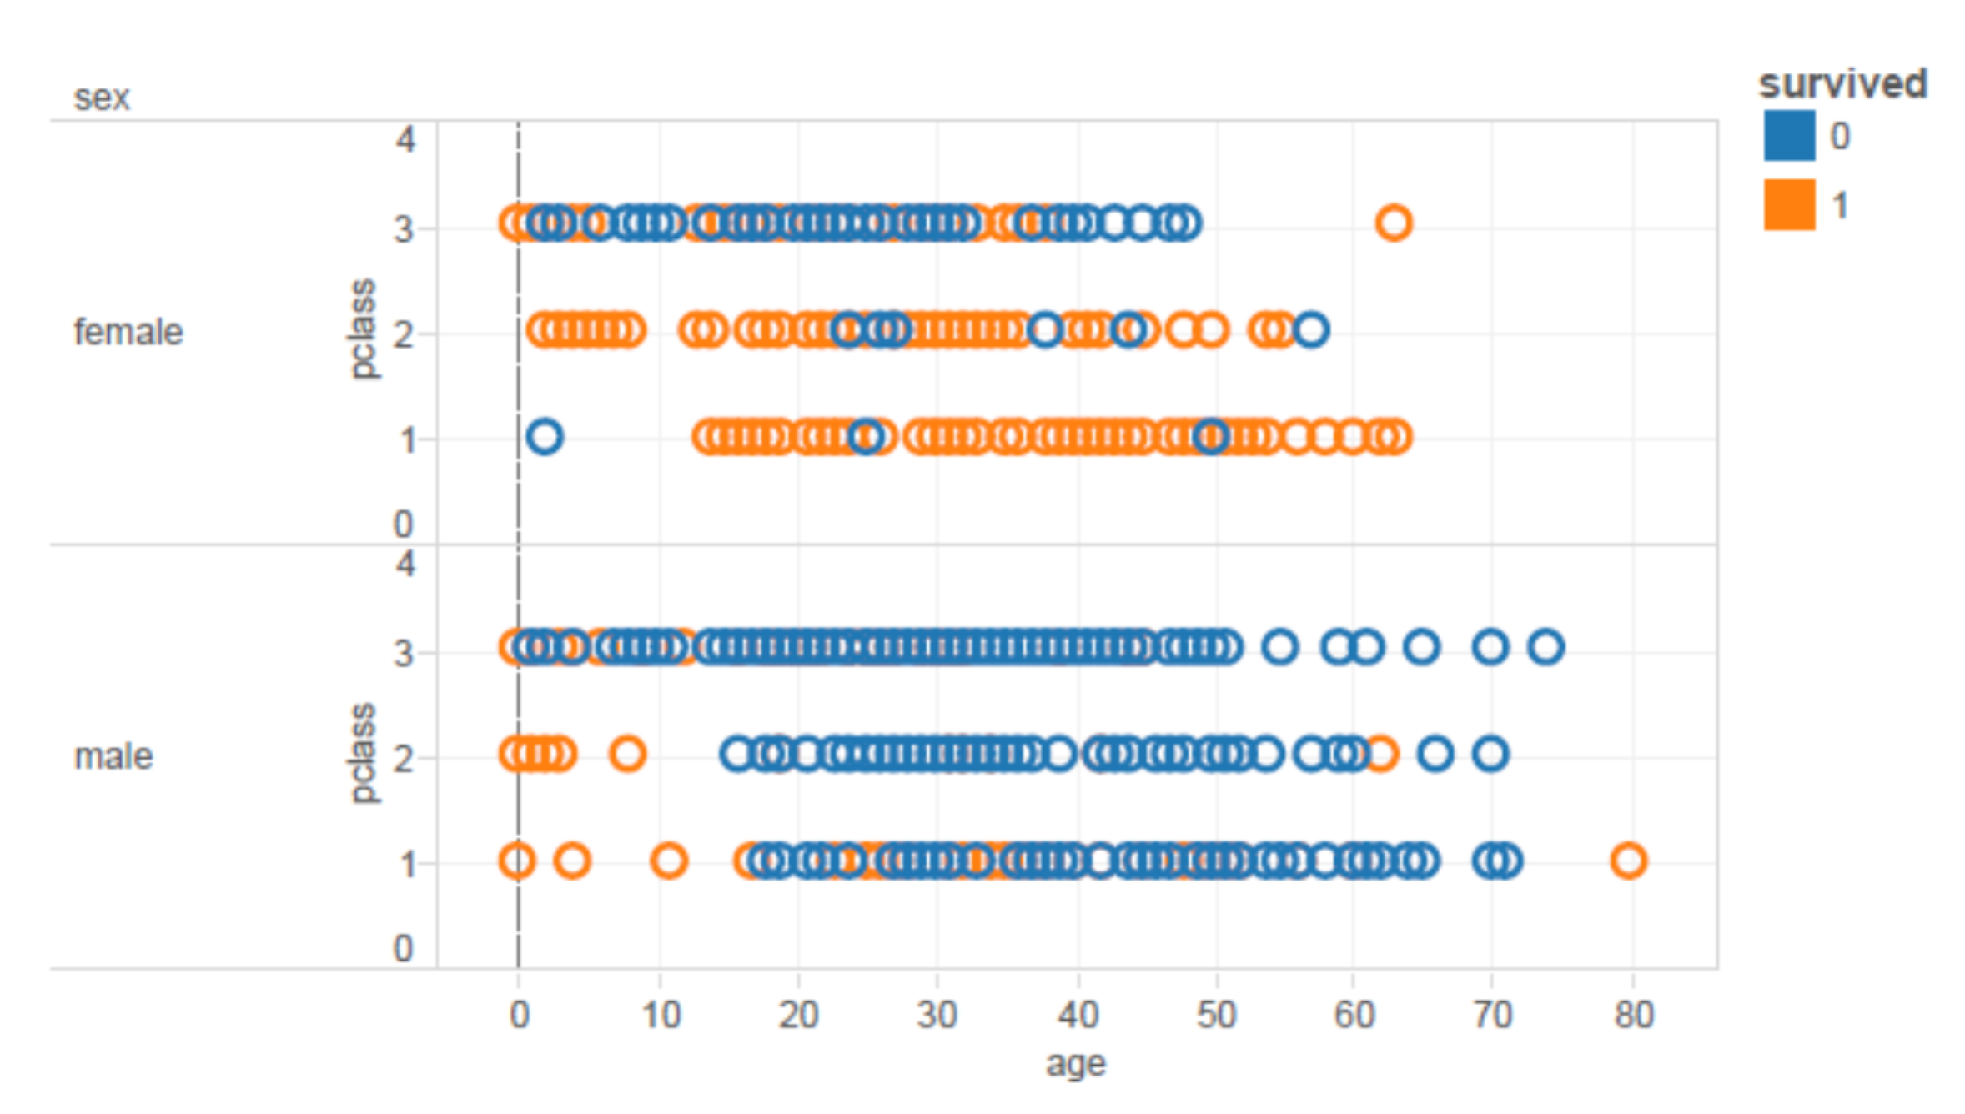

Fig. Expected Results